

**American International University-Bangladesh**

**Faculty of Science and Information Technology**

**Department of Computer Science**

**Introduction to Database [H]**

|  |
| --- |
| **Semester: Fall 2020-21** |

|  |  |
| --- | --- |
| Student ID | Student Name |
| 19-41283-3 | Nafiz Ahmed |
| 19-41289-3 | Anik Kumar Saha |
| 19-41292-3 | Ayesha Akhtar |
| 19-41293-3 | Tonmoy Saha Choyon |

**Project name: Restaurant management**

**Scenario of Restaurant management**

* A customer has a unique customer ID, name, phone number, table number of where the customer is sitting and order of what the customer is ordering.
* The restaurant has a menu which is identified by price, item name, cuisine and item ID for each items.
* Customers check the menu to order foods.
* Then customers give orders where each order contains item ID, a distinct order ID for each order, customer ID, cooking time and price of that item.
* The orders from customers are taken by waiters who has a name, a unique ID, salary and working hour.
* The manager takes the orders from waiters and tells the chefs to cook them where the manager has name, a unique ID, phone number, salary and the chefs have information like name, joining date, a separate ID for each chef, shift that tells in which shift the chefs work and their salaries.
* Chefs prepare the given orders.
* Then the prepared foods are delivered to the customers by waiters.
* Lastly customers receive receipts by a cashier where receipts contain information about almost everything like customer ID, price of a specific food, order ID, total cost, quantity of the foods and a receipt number that makes the receipt unique.
* And the cashier who prints the receipts holds name, salary, a distinct ID and working hour.

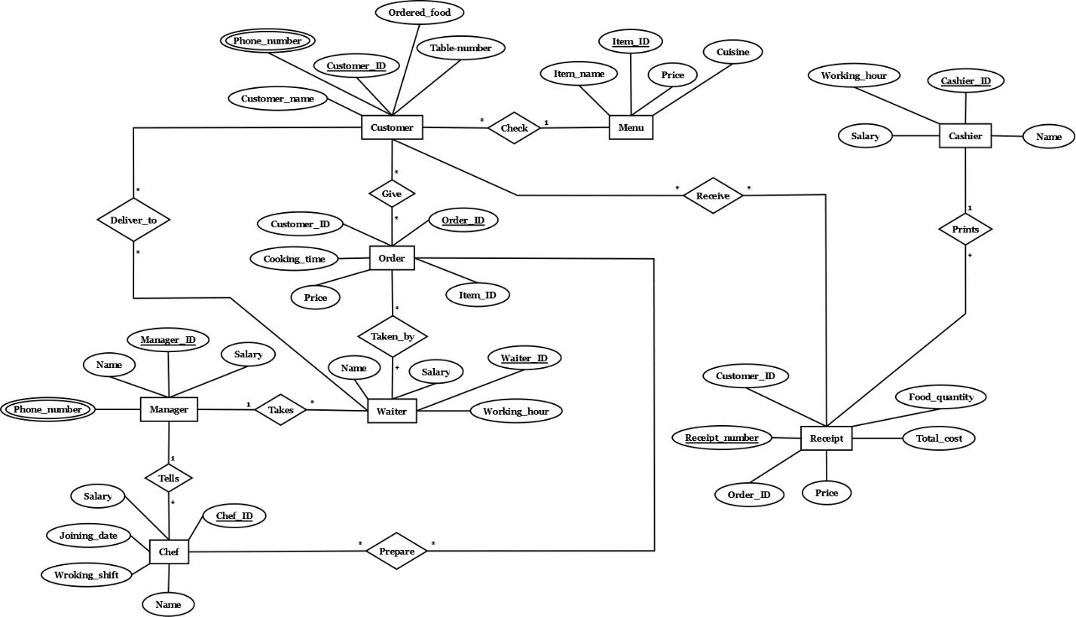E-R model:

**Normalization**

* **Primary key**
* **Foreign key**
* **Composite primary key**

**Check**- (Customer_ID, Customer_name, Table_number, Phone_number, Ordered_food, Item_ID, Item_name, Price, Cuisine)

1NF- Phone_number is a multivalued attribute.

2NF-

* Customer_ID, Customer_name, Table_number, Phone_number, Ordered_food
* Item_ID, Item_name, Price, Cuisine

3NF- No transitive dependency

* Customer_ID, Customer_name, Table_number, Phone_number, Ordered_food
* Item_ID, Item_name, Price, Cuisine

Table for Check-

1. Customer_ID, Customer_name, Table_number, Ordered_food, Item_ID
2. Item_ID, Item_name, Price, Cuisine
3. Customer_ID, Phone_number

**Receive**- (Customer_ID, Customer_name, Table_number, Phone_number, Ordered_food, Receipt_number, Food_quantity, Total_cost, price)

1NF- Phone_number is a multivalued attribute.

2NF-

* Customer_ID, Customer_name, Table_number, Phone_number, Ordered_food
* Receipt_number, Food_quantity, Total_cost, price

3NF-

* Customer_ID, Customer_name, Table_number, Phone_number, Ordered_food
* Receipt_number, Food_quantity
* Cost_ID, Total_cost, price

Table for Receive-

1. Customer_ID, Customer_name, Table_number, Ordered_food
2. Receipt_number, Food_quantity, Cost_ID
3. Customer_ID, Phone_number
4. Cost_ID, Total_cost, price
5. CR_ID, Customer_ID, Receipt_number

**Give**- (Customer_ID, Customer_name, Table_number, Phone_number, Ordered_food, Order_ID, Cooking_time, Price)

1NF- Phone_number is a multivalued attribute.

2NF-

* Customer_ID, Customer_name, Table_number, Phone_number, Ordered_food
* Order_ID, Cooking_time, Price

3NF- No transitive dependency

* Customer_ID, Customer_name, Table_number, Phone_number, Ordered_food
* Order_ID, Cooking_time, Price

Table for Give-

1. Customer_ID, Customer_name, Table_number, Ordered_food
2. Order_ID, Cooking_time, Price
3. Customer_ID, Phone_number
4. Food_ID, Customer_ID, Order_ID

**Prints**- (Cashier_ID, Cashier_name, Salary, Working_hour, Receipt_number, Food_quantity, Total_cost, price)

1NF- There is no multivalued attribute.

2NF-

* Cashier_ID, Cashier_name, Salary, Working_hour
* Receipt_number, Food_quantity, Total_cost, price

3NF-

* Cashier_ID, Cashier_name, Salary, Working_hour
* Receipt_number, Food_quantity
* Cost_ID, Total_cost, price

Table for Prints-

1. Cashier_ID, Cashier_name, Salary, Working_hour
2. Receipt_number, Food_quantity, Cashier_ID, Cost_ID
3. Cost_ID, Total_cost, price

**Taken_by**- (Order_ID, Cooking_time, Price, Waiter_ID, Waiter_name, Salary, Working_hour)

1NF- There is no multivalued attribute.

2NF-

* Order_ID, Cooking_time, Price
* Waiter_ID, Waiter_name, Salary, Working_hour

3NF- No transitive dependency.

* Order_ID, Cooking_time, Price
* Waiter_ID, Waiter_name, Salary, Working_hour

Table for Taken_by-

1. Order_ID, Cooking_time, Price
2. Waiter_ID, Waiter_name, Salary, Working_hour
3. OW_ID, Order_ID, Waiter_ID

**Prepare**- (Order_ID, Cooking_time, Price, Chef_ID, Chef_name, Salary, Working_hour, Joining_date)

1NF- There is no multivalued attribute.

2NF-

* Order_ID, Cooking_time, Price
* Chef_ID, Chef_name, Salary, Working_hour, Joining_date

3NF- No transitive dependency.

* Order_ID, Cooking_time, Price
* Chef_ID, Chef_name, Salary, Working_hour, Joining_date

Table for Prepare-

1. Order_ID, Cooking_time, Price
2. Chef_ID, Chef_name, Salary, Working_hour, Joining_date
3. OC_ID, Order_ID, Chef_ID

**Takes**- (Manager_ID, Manager_name, Salary, Phone_number, Waiter_ID, Waiter_name, Salary, Working_hour)

1NF- Phone_number is a multivalued attribute.

2NF-

* Manager_ID, Manager_name, Salary, Phone_number
* Waiter_ID, Waiter_name, Salary, Working_hour

3NF- No transitive dependency.

* Manager_ID, Manager_name, Salary, Phone_number
* Waiter_ID, Waiter_name, Salary, Working_hour

Table for Takes-

1. Manager_ID, Manager_name, Salary
2. Manager_ID , Phone_number
3. Waiter_ID, Waiter_name, Salary, Working_hour, Manager_ID

**Tells**- (Manager_ID, Manager_name, Salary, Phone_number, Chef_ID, Chef_name, Salary, Working_hour, Joining_date)

1NF- Phone_number is a multivalued attribute.

2NF-

* Manager_ID, Manager_name, Salary, Phone_number
* Chef_ID, Chef_name, Salary, Working_hour, Joining_date

3NF- No transitive dependency.

* Manager_ID, Manager_name, Salary, Phone_number
* Chef_ID, Chef_name, Salary, Working_hour, Joining_date

Table for Tells-

1. Manager_ID, Manager_name, Salary
2. Manager_ID , Phone_number
3. Chef_ID, Chef_name, Salary, Working_hour, Joining_date, Manager_ID

**Deliver_to**- (Customer_ID, Customer_name, Table_number, Phone_number, Ordered_food, Waiter_ID, Waiter_name, Salary, Working_hour)

1NF- Phone_number is a multivalued attribute.

2NF-

* Customer_ID, Customer_name, Table_number, Phone_number, Ordered_food
* Waiter_ID, Waiter_name, Salary, Working_hour

3NF- No transitive dependency.

* Customer_ID, Customer_name, Table_number, Phone_number, Ordered_food
* Waiter_ID, Waiter_name, Salary, Working_hour

Table for Deliver_to-

1. Customer_ID, Customer_name, Table_number, Ordered_food
2. Customer_ID, Phone_number
3. Waiter_ID, Waiter_name, Salary, Working_hour
4. WC_ID, Customer_ID, Waiter_ID

**Total tables:**

1. Customer_ID, Customer_name, Table_number, Ordered_food, Item_ID
2. Item_ID, Item_name, Price, Cuisine
3. Customer_ID, Phone_number
4. Customer_ID, Customer_name, Table_number, Ordered_food **(REMOVE)**
5. Receipt_number, Food_quantity, Cost_ID **(REMOVE)**
6. Customer_ID, Phone_number **(REMOVE)**
7. Cost_ID, Total_cost, price
8. CR_ID, Customer_ID, Receipt_number
9. Customer_ID, Customer_name, Table_number, Ordered_food **(REMOVE)**
10. Order_ID, Cooking_time, Price
11. Customer_ID, Phone_number **(REMOVE)**
12. Food_ID, Customer_ID, Order_ID
13. Cashier_ID, Cashier_name, Salary, Working_hour
14. Receipt_number, Food_quantity, Cashier_ID, Cost_ID
15. Cost_ID, Total_cost, price **(REMOVE)**
16. Order_ID, Cooking_time, Price **(REMOVE)**
17. Waiter_ID, Waiter_name, Salary, Working_hour **(REMOVE)**
18. OW_ID, Order_ID, Waiter_ID
19. Order_ID, Cooking_time, Price **(REMOVE)**
20. Chef_ID, Chef_name, Salary, Working_hour, Joining_date **(REMOVE)**
21. OC_ID, Order_ID, Chef_ID
22. Manager_ID, Manager_name, Salary
23. Manager_ID , Phone_number
24. Waiter_ID, Waiter_name, Salary, Working_hour, Manager_ID
25. Manager_ID, Manager_name, Salary **(REMOVE)**
26. Manager_ID , Phone_number **(REMOVE)**
27. Chef_ID, Chef_name, Salary, Working_hour, Joining_date, Manager_ID
28. Customer_ID, Customer_name, Table_number, Ordered_food **(REMOVE)**
29. Customer_ID, Phone_number **(REMOVE)**
30. Waiter_ID, Waiter_name, Salary, Working_hour **(REMOVE)**
31. WC_ID, Customer_ID, Waiter_ID

**Final tables:**

|  |  |
| --- | --- |
| **Table name** | **Column name** |
| 1. Customer | Customer_ID, Customer_name, Table_number, Ordered_food, Item_ID |
| 1. Item | Item_ID, Item_name, Price, Cuisine |
| 1. C_phone | Customer_ID, Phone_number |
| 1. Cost | Cost_ID, Total_cost, price |
| 1. C_receipt | CR_ID, Customer_ID, Receipt_number |
| 1. Order_info | Order_ID, Cooking_time, Price |
| 1. Food | Food_ID, Customer_ID, Order_ID |
| 1. Cashier | Cashier_ID, Cashier_name, Salary, Working_hour |
| 1. Receipt | Receipt_number, Food_quantity, Cashier_ID, Cost_ID |
| 1. W_order | OW_ID, Order_ID, Waiter_ID |
| 1. Ch_order | OC_ID, Order_ID, Chef_ID |
| 1. Manager | Manager_ID, Manager_name, Salary |
| 1. M_phone | Manager_ID , Phone_number |
| 1. Waiter | Waiter_ID, Waiter_name, Salary, Working_hour, Manager_ID |
| 1. Chef | Chef_ID, Chef_name, Salary, Working_hour, Joining_date, Manager_ID |
| 1. C_waiter | WC_ID, Customer_ID, Waiter_ID |

**All Tables and Data**

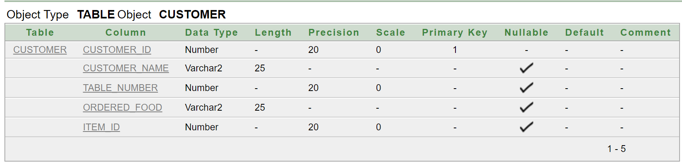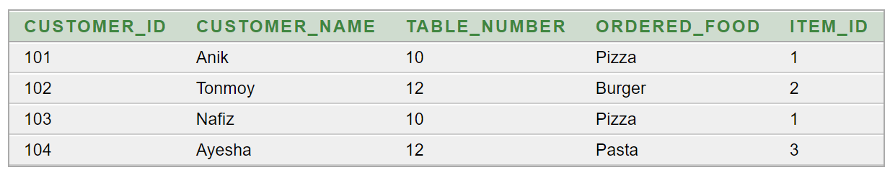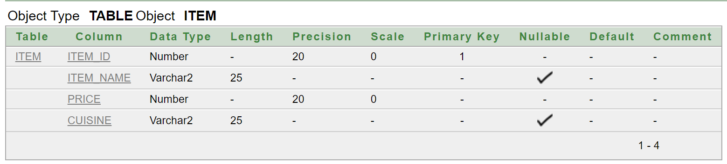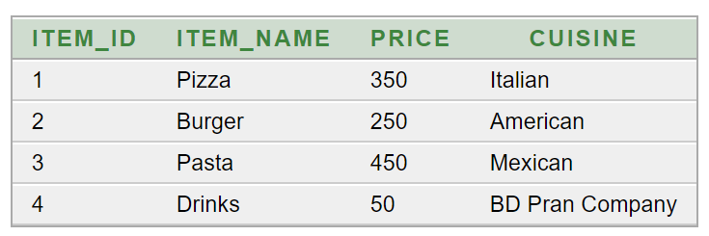

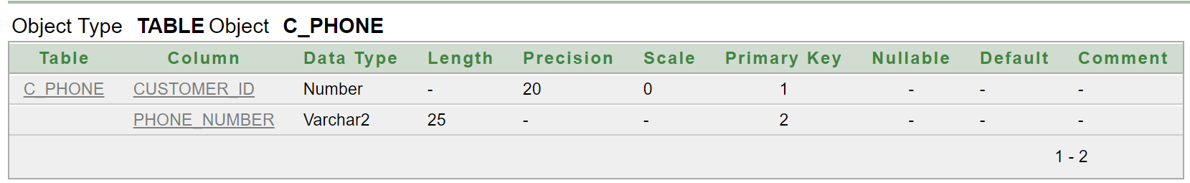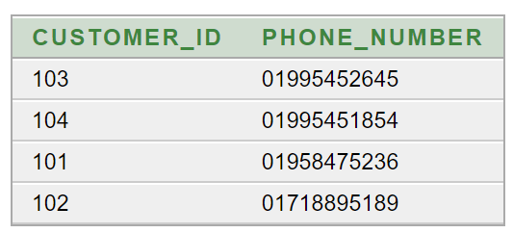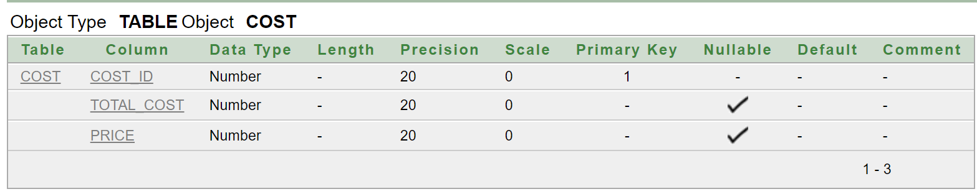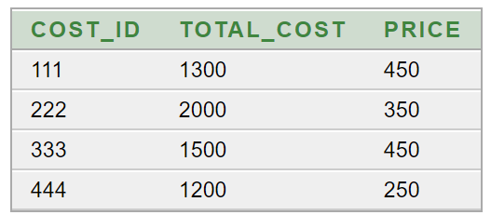

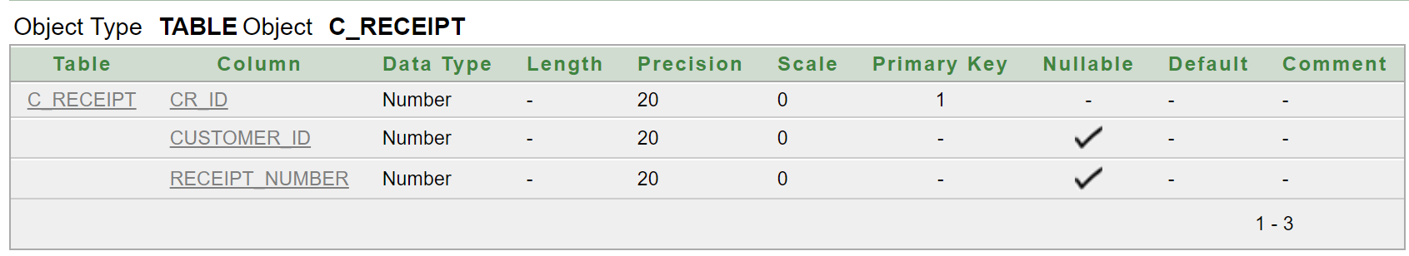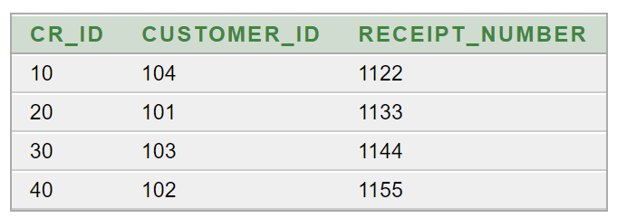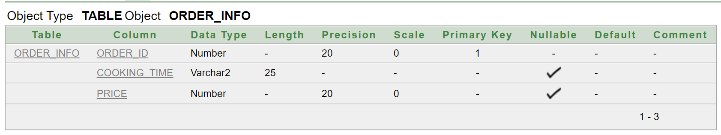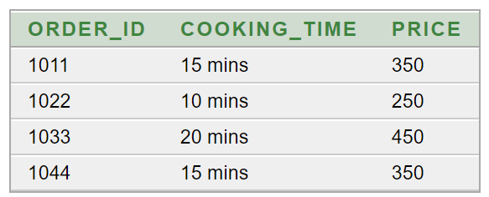

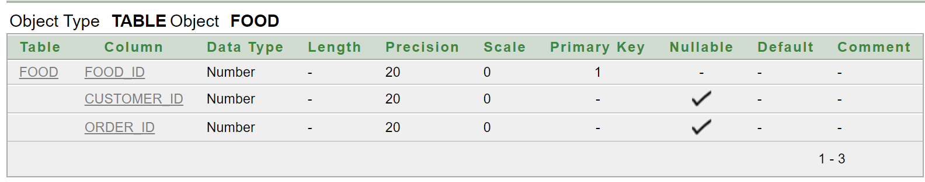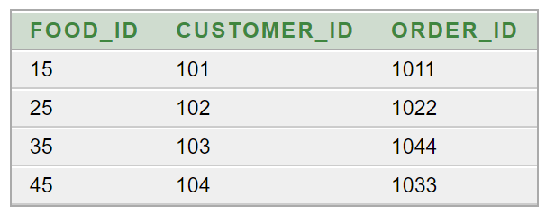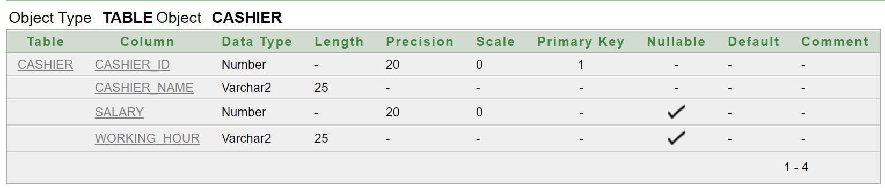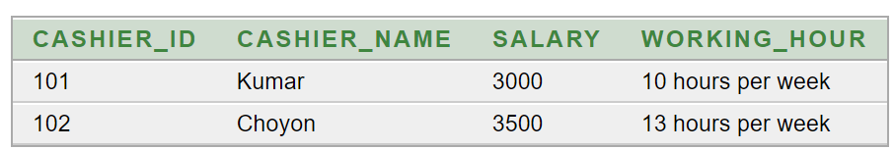

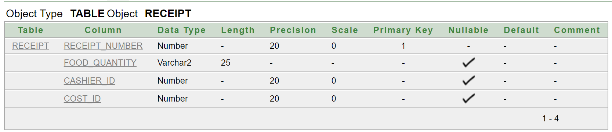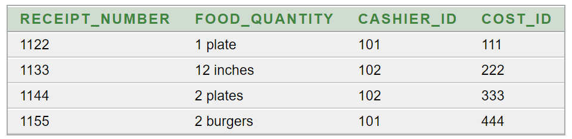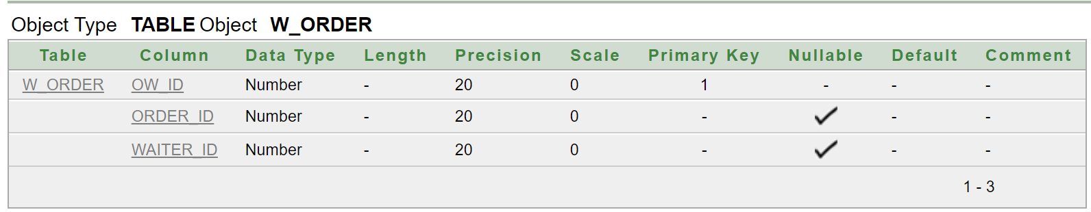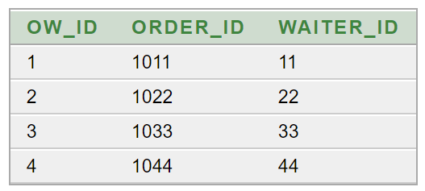

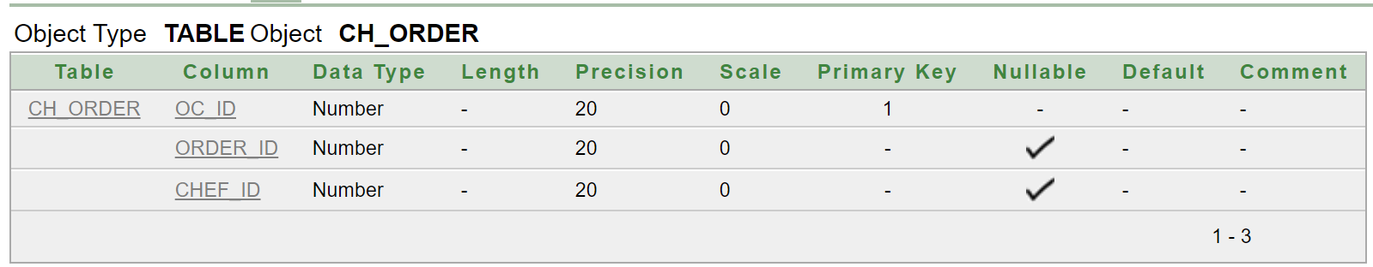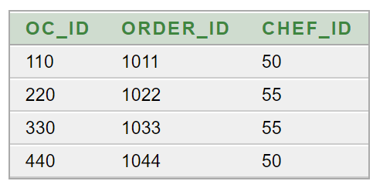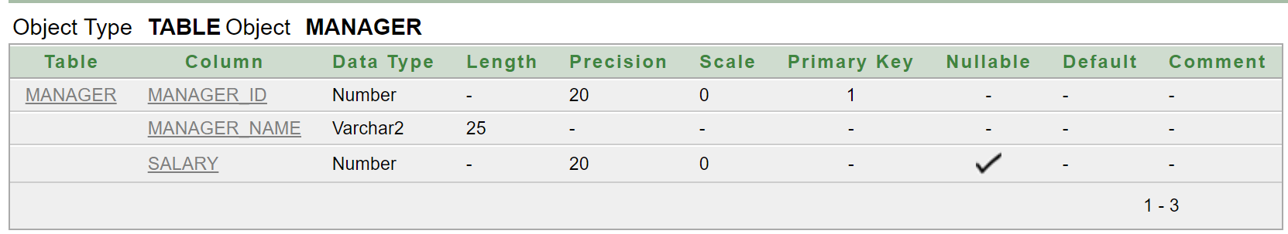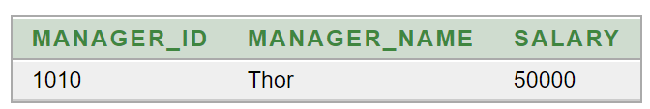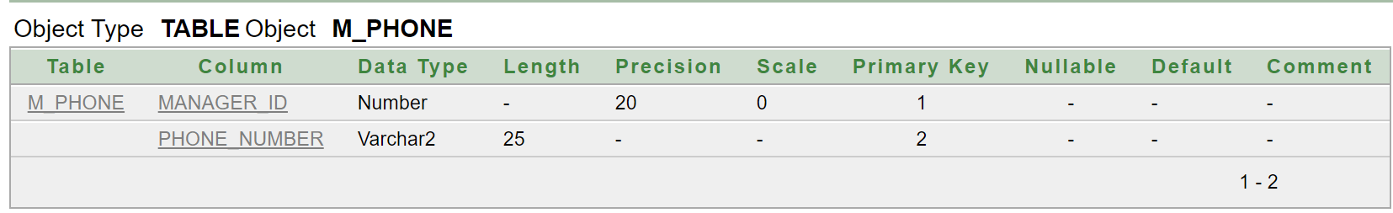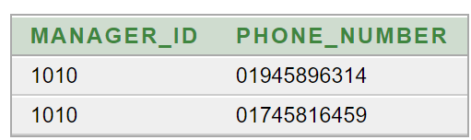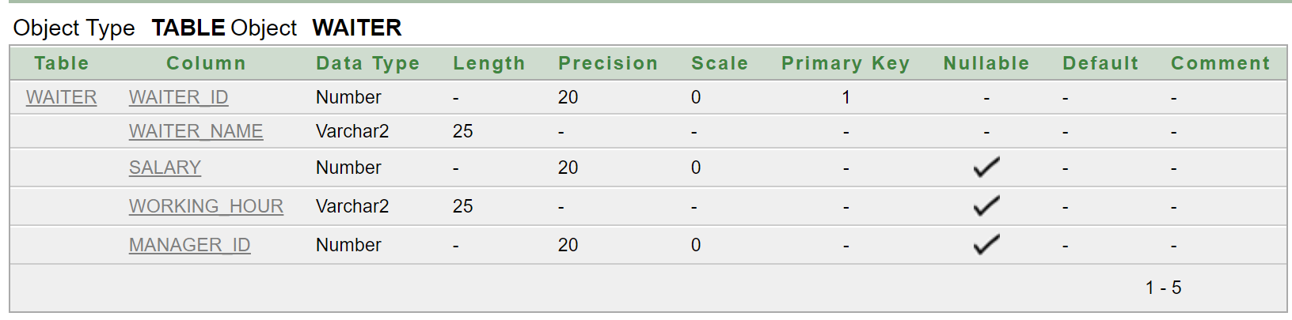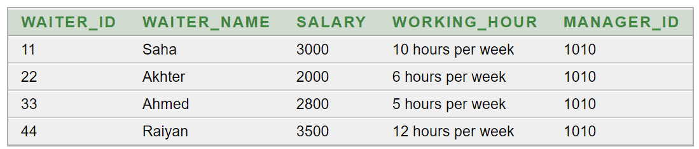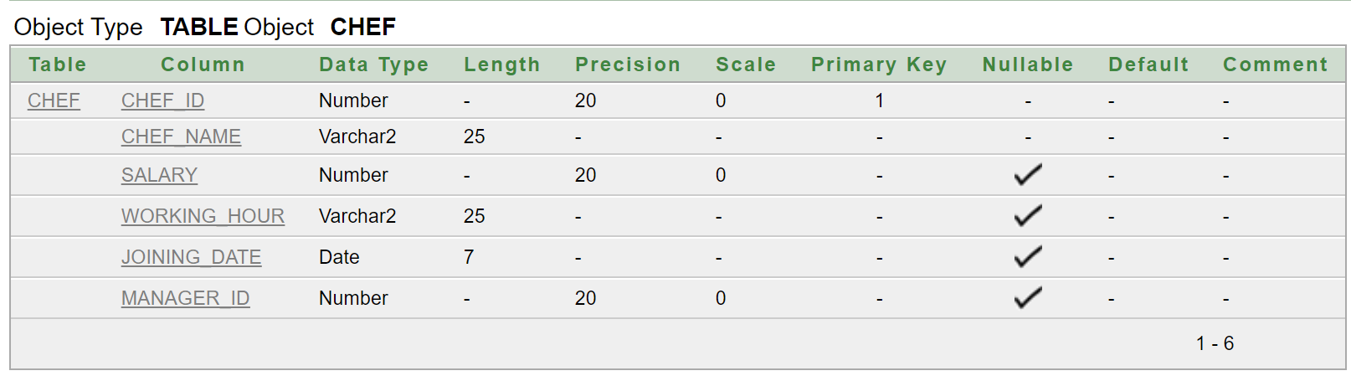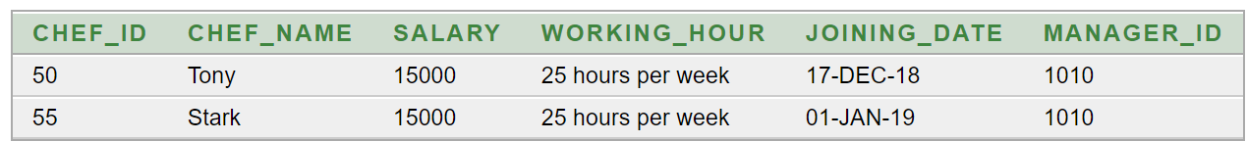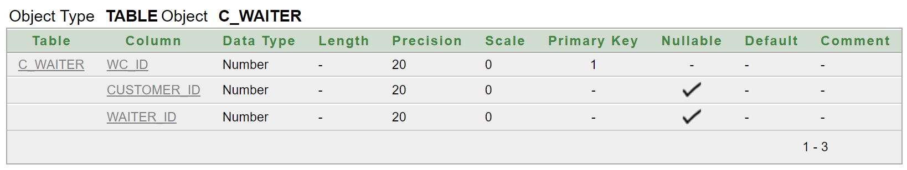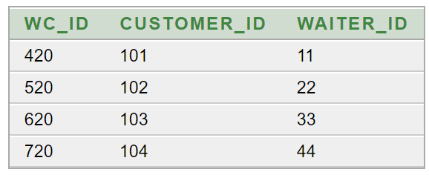

**Questions**

**Join**

1. **Write a query to display which customer ordered what from Customer table along with item price and cuisine from Item table in ascending order based on food's prices.**
2. **Write a query to display receipt number, food quantity from Receipt table and total cost from Cost table.**
3. **Write a query to display manager’s name from Manager table and phone number from M_phone table where phone number is not Banglalink.**

**Single row sub-query**

1. **Write a query to display all the waiters’ information from Waiter table whose salary is less than the second highest salary holder.**
2. **Write a query to display the cashier's information from Cashier table whose salary is higher than the cashier who has 'a' in the 4rth position of their names.**

**Multiple row sub-query and Join**

1. **Write a query to display customer's name, ordered food from Customer table and ordered food's price from Item table whose ordered food's price is equal to the price of those customers ordered food who have 'a' in their names.**

**View and Join**

1. **Create a view table to show all the customer's name from Customer table and phone number from C_phone table who at least ate something.**
2. **Create a view table to show manager's name from Manager table and phone number from M_phone table and then modify the table to set it as read only mode.**

**Date functions**

1. **Write a query to display chef name, salary, working hour, joining date, total months of working, date after adding 5 months with joining date, date of next Friday from joining date, last date of joining month from Chef table whose working experience in this restaurant is more than 20 months.**

**Group functions**

1. **Write a query to display maximum salary, minimum salary, average salary and summation of salaries of those waiters who don't have 'd' in their names from Waiter table.**

**THE END**